Quotation for VPS Hosting (Hostinger - KVM 8 Plan)

Please find below the quotation for the recommended VPS server plan from Hostinger. We suggest opting for the KVM 8 plan, which offers excellent performance according to EMR requirements.

# Plan Details:

- Plan: KVM 8 (VPS Hosting)  
- CPU: 8 vCPU Cores  
- RAM: 32 GB  
- Storage: 400GB GB NVMe Disk Space  
- Bandwidth: 32 TB  
- Daily Auto-Backup: Included  
- Free Domain: 1 year

# Pricing Options:

|  |  |
| --- | --- |
| Plan Duration | Total Amount (PKR) |
| 12 Months | **157,176.00** |

# Reference:

Below are the captured screenshots of the VPS KVM 4 plan details and pricing for your reference.

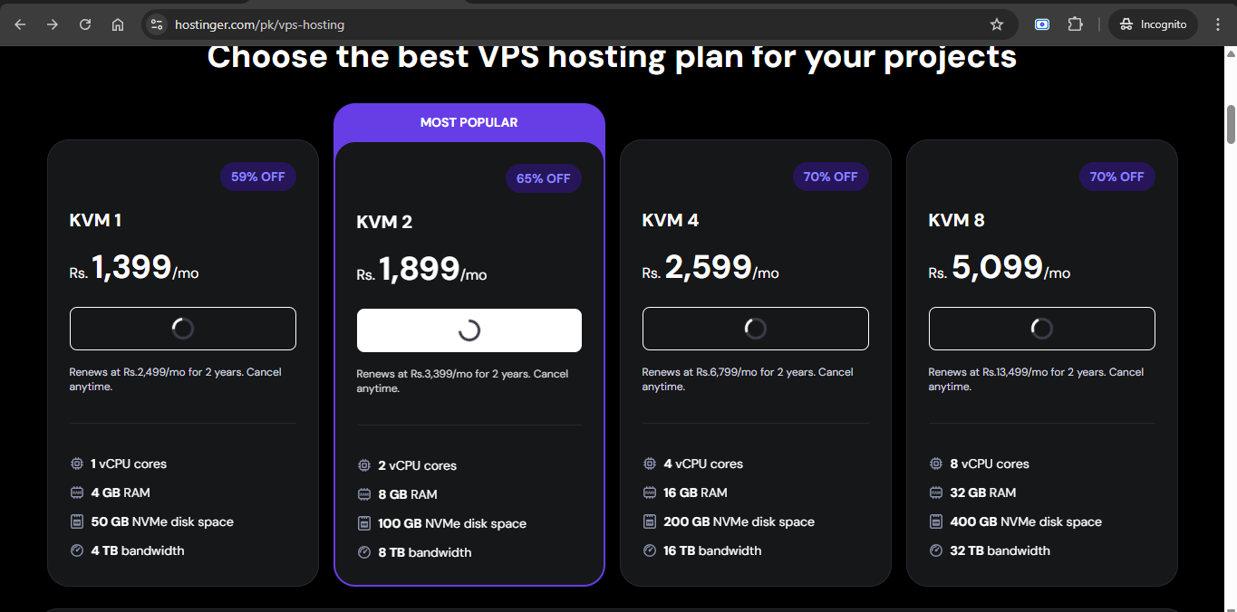

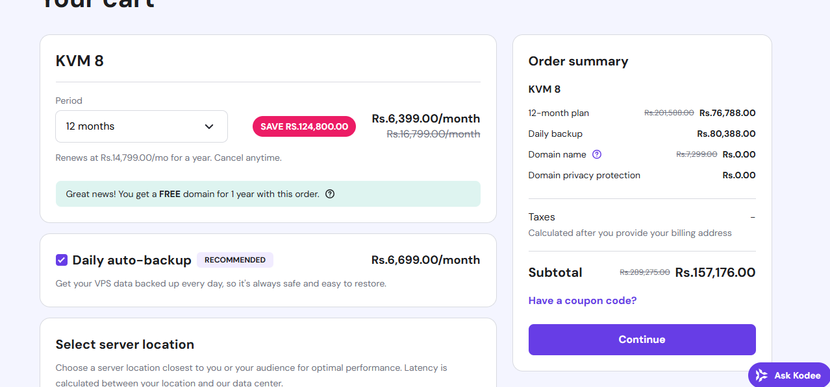

Reference: <https://www.hostinger.com/pk/vps-hosting>